Tableau Tutorial:

**Tableau:**

* Tableau is a powerful data visualization tool used in the business intelligence industry.
* It simplifies the raw data into a very easily understandable format.
* It visualizes and creates interactive, sharable dashboards.
* Tableau is not required any technical or programming skills.

**Tableau Installation:**

* **How to install Crack version of Tableau**

step 1 : Go to below URL

https://drive.google.com/drive/u/2/folders/1Avjh5n1OAcH2OS0MegENzfSgiN8TCTEg

step 2 : download set up file and run it.

step 3 : download tabui.dll file and replace or paste in below location

C:\Program Files\Tableau\Tableau 2019.3\bin

step 4 : close all th paths and go to strat menu & type tableau and open.

* **14 days trail Period**

Navigate to the below URL and download 14 days trial version of Tableau Desktop

URL: <https://www.tableau.com/>

1. Click on Free trail



1. After click on free trail it will navigate to next window

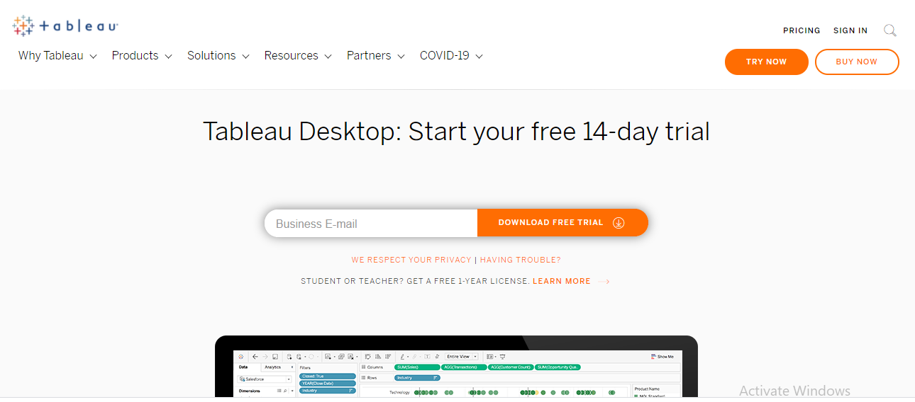

1. Enter your email id and click on download then it will download below file

File: TableauDesktop-64bit-2021-2-0

1. Click and run it will install tableau.

**There are three main features of Tableau, such as:**

1. **Data Blending:** Data blending is an essential feature in Tableau. It is used when we combine related data from multiple data sources, which you want to analyze together in a single view, and represent in the form of a graph.
2. **Real-time Analysis:** Real-Time Analysis makes users able to quickly understand and analyze dynamic data when the Velocity is high, and real-time analysis of data is complicated. Tableau can help extract valuable information from fast-moving data with interactive analytics.
3. **The Collaboration of Data:** Data analysis is not isolating task. That's why Tableau is built for collaboration. Team members can share data, make follow up queries, and forward easy-to-digest visualizations to others who could gain value from the data. Making sure everyone understands the data and can make informed decisions is critical to success.

**Tableau tools:**

1. **Tableau Desktop:** Tableau Desktop establishes connectivity between the Data Warehouse and other various types of files. The dashboards and the workbooks created here can be either shared locally or publicly. It allows us to code and customizes reports. Right from establishing the stories, charts to blending them all to form a dashboard, all the necessary work is created in Tableau Desktop.
2. **Tableau Public:** This Tableau version is specially built for cost-effective users. The word '**Public**' means that the created workbooks cannot be saved locally. They should be kept on the Tableau's public cloud, which can be accessed and viewed by anyone.
3. **Tableau Online:** Its functionality is similar to the Tableau server, but data is stored on the server that hosted on the cloud, which is maintained by the Tableau group. There is no storage limit on the data which is published in the Tableau Online. Tableau Online creates a direct link over 40 data sources who are hosted in the cloud such as the **Hive, MySQL, Spark SQL, Amazon Aurora**, and many more.
4. **Tableau Server:** The software is correctly used to share the workbooks, visualizations, which is created in the Tableau Desktop application over the organization. To share dashboards in the Tableau Server, you should first publish your workbook in the Tableau Desktop. Once the workbook has been uploaded to the server, it will be accessible only to the authorized users.
5. **Tableau Reader:** Tableau Reader is a free tool which allows us to view the visualizations and workbooks, which is created using Tableau Desktop or Tableau Public. The data can be filtered, but modifications and editing are restricted. There is no security in Tableau Reader as anyone can view workbook using Tableau Reader.

**There are several types of data terminologies in Tableau, such as:**

1. **Bookmark:** A .tbm document in the bookmarks folder in the Tableau repository that contains a single worksheet. It helps in improving data analysis. Unlike, web browser bookmarks, .tbm files are a compatible way to display various studies quickly.
2. **Workbook:** A workbook is a file with .twb extension that holds one or more worksheets as well as dashboards and stories.
3. **Dashboard:** The dashboard is a combination of several views that are arranged on a single page. In Tableau, dashboards are used to observe and compare a variety of data together, and also it allows interacting with other worksheets.
4. **Data Source Page:** Data Source is a page where you can set up your data source. Does this data source page generally consist of four main areas? Join area, left pane, a preview area, and metadata area.
5. **Worksheet:** The worksheet is a collection of sheets. It's a place where you build views of your data by dragging various fields onto the shelves.
6. **Dimensions:** Dimension is commonly known as a field of categorical data. Dimensions hold discrete data such as members and hierarchies that cannot be aggregated. It also contains characteristic values such as dates, names, and geographical data. The dimensions used to reveal details of your information.
7. **Measures:** measures are the measurable quantities of the data, which can be analyzed by a dimension table. Measures are stored in a table which contains foreign keys referring uniquely to the associated dimension tables. The table supports data storage at the atomic level and thus, allows the number of records to be inserted at one time.  
   **For example**, a Sales table can have a product key, customer key, promotion key, items sold, referring to a specific event.
8. **Filters shelf:** Filter shelf is located on the left side of the workbook. Filters shelf is used to exclude the data from a view by filtering it using both dimensions and measures.
9. **Pages shelf:** Page shelf is on the left side of the view. With the help of the page shelf, you can split a view into a sequence of pages based on the values and members in a continuous or discrete field. Adding a field with the pages shelf is similar to adding a field in rows shelf. For each new row, a new page is created.
10. **Marks card:** Marks card is on the left side of the worksheet. The user can drag fields to the control mark properties such as color, type, shape, size, label, detail, and tooltip.

**Difference between .twb and .twbx extension:**

|  |  |
| --- | --- |
| **.twb** | **.twbx** |
| A .twb is an xml document that contains the information about your dashboards, sheets, and stories. | It doesn't contain any data so to share your workbook, and you have send both workbook file and the data source file of Tableau. |
| A .twbx is a package of files "compressed" together. | It includes data source file and any other file used to produce the workbook, including images. |

**Difference between traditional BI tools and Tableau:**

|  |  |
| --- | --- |
| **Traditional BI tools** | **Tableau** |
| Traditional BI architecture has hardware limitations. | Tableau doesn't have dependencies. |
| It based on the complex set of technologies. | Tableau based associative search that makes it fast and dynamic. |
| It does not support in-memory, multi-thread, and multi-core computing. | It supports in-memory when used with advanced technologies. |
| It has a predefined view of data. | It uses predictive analysis for various business operations. |